Derive the requested differential equation models for a baking cookie as a function of time (t) and cookie temperature (T) (along with situational parameters such as area, volume, etc., and the assumptions given below). Please read the assumptions before starting your solutions.

1. (5 points) Draw an appropriate picture of the system describing the baking process. Clearly define any parameters used in the model, including their dimensions (so you can check for dimensional consistency in your models).
2. (5 points) Derive the differential equation model for density of the cookie as a function of time, d/dt, including the assumptions below.
3. (5 points) Derive the differential equation model for temperature of the cookie as a function of time, d/dt, including the assumptions below and the density model from part b, as needed.
4. (5 points) Demonstrate that your models are dimensionally consistent.

Assumptions:

1. Assume a cookie is a flat cylinder (radius R, thickness x) which is baked by putting it into a hot oven environment at a constant temperature, Th. The initial density of the cookie is o and the cookie’s initial temperature is To.

2. During the baking process, the cookie loses water (moisture).

3. Assume the cookie’s internal density, , and temperature, T, are uniform within the cookie, i.e. the cookie’ properties do not vary spatially within the cookie.

4. During the baking process, heat enters the cookie. Assume this heat transfer occurs from the oven environment to the cookie following Newton’s law for convective heat transfer, i.e. Q = h A (T – Th), where A is the area of the cookie, h is the heat transfer coefficient, and Q is the rate of heat transfer (energy/time). (Note: You should determine the units of h, so you can to check for dimensional consistency.)

5. You may assume that the cookie volume is constant as it bakes. Note, however, that the density changes since water is lost as the baking process occurs.

6. Since we do not know the details of how water migration and evaporation from the cookie surface occurs, assume that the rate of water loss is proportional to the temperature of the cookie, i.e. T. (Note: You should determine the dimensions of  so you can check for dimensional consistency.)

7. You may assume that any chemical reactions that occur during the baking process do not affect the temperature or mass of the cookie.

1. **(5 points) Draw an appropriate picture of the system describing the baking process. Clearly define any parameters used in the model, including their dimensions (so you can check for dimensional consistency in your models).**

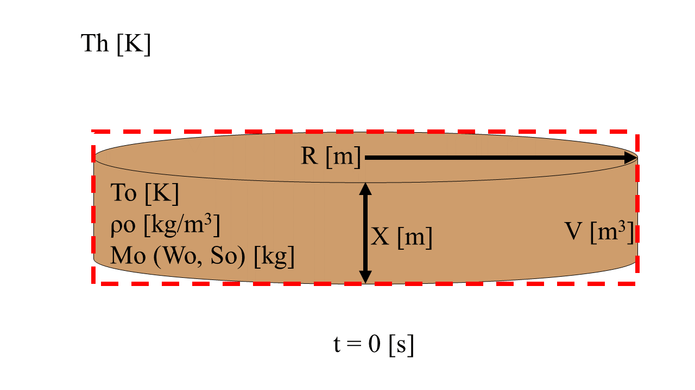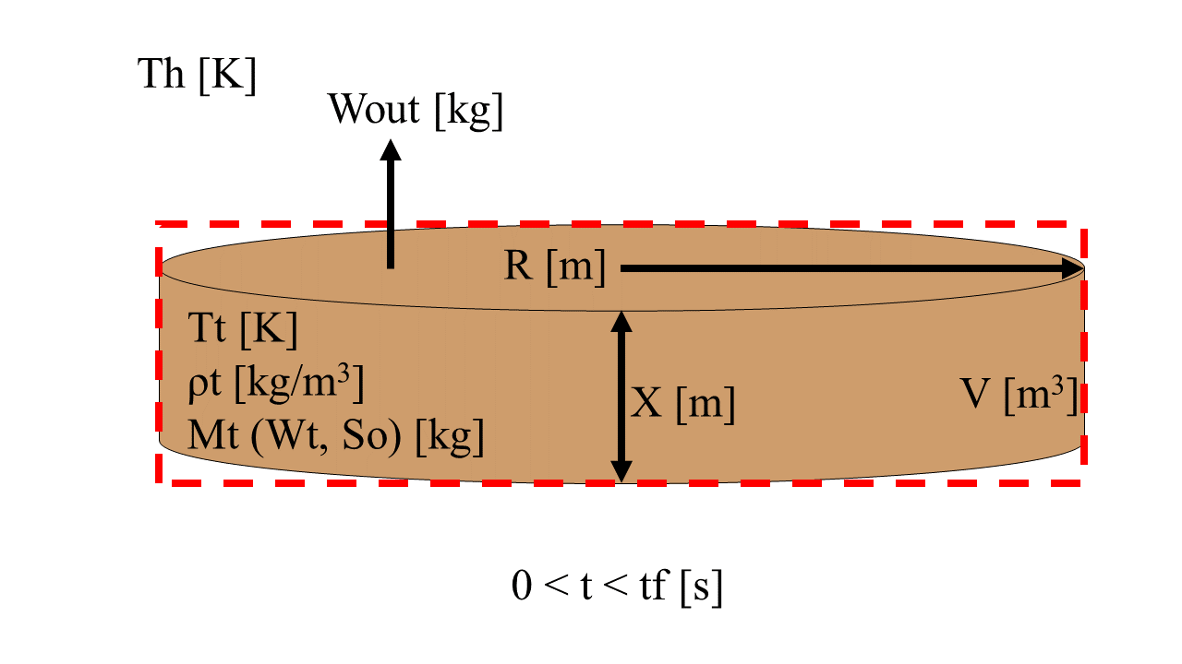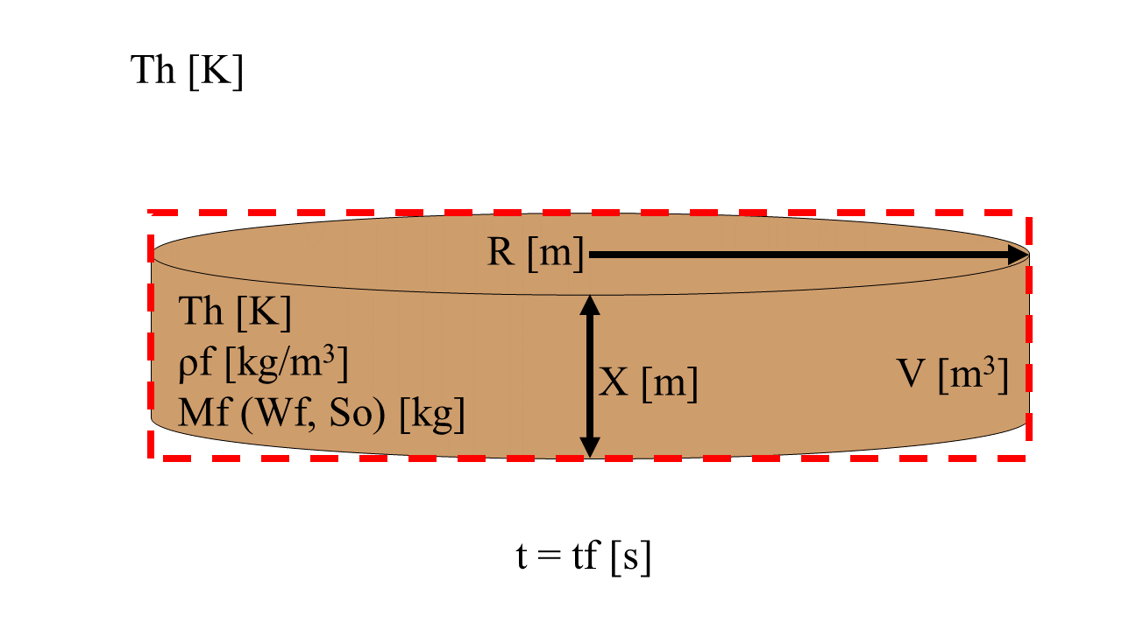

Figure 1: Pictures of the system at different time points in the experiment: the beginning, the middle, and the end. The parameters of the system and its surrounding are labeled with units in brackets. The system boundary is defined as the red dotted line.

1. (5 points) Derive the differential equation model for density of the cookie as a function of time, d/dt, including the assumptions below.

ρ = M/V

M = W + S

Assuming S mass stays stable

dM/dt =